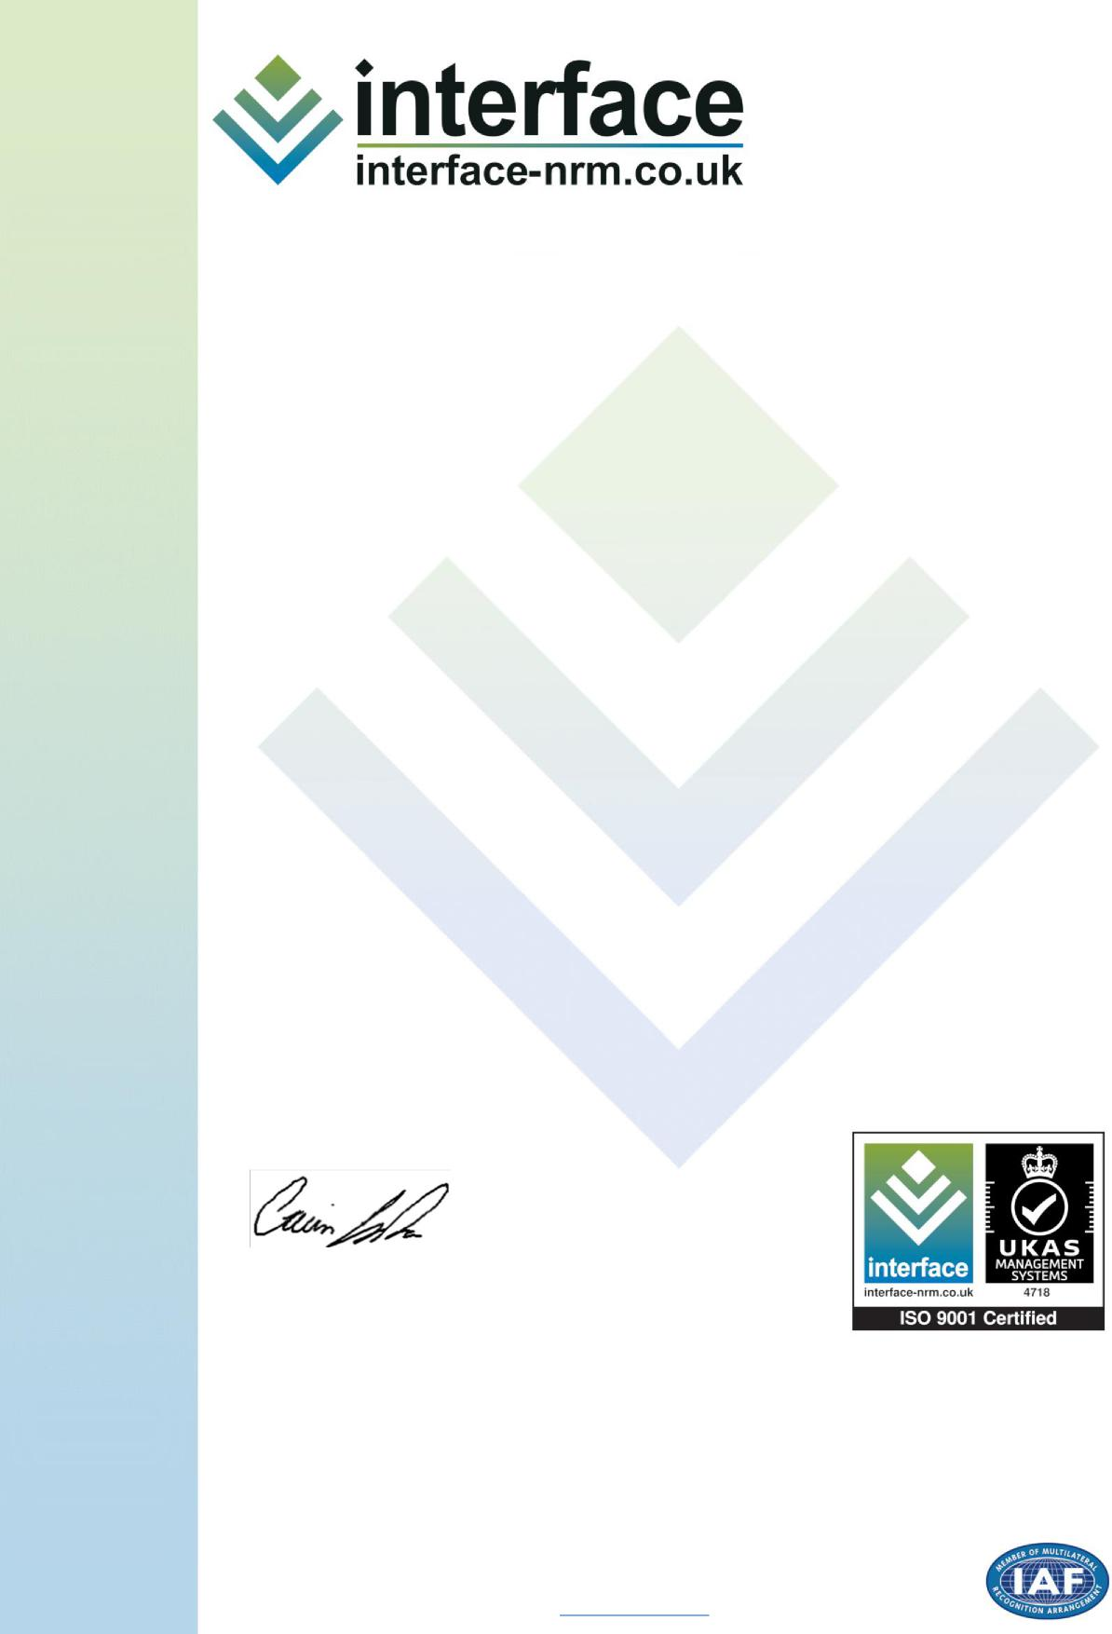

CERTIFICATE O F REGISTRATION

**QUALITY MANAGEMENT SYSTEM: BS EN ISO 9001:2015**

This is to certify that:

**Whiting Landscape Ltd**

Wildmoor Lane
  
Catshill

Bromsgrove

Worcestershire
  
B61 0RJ

United Kingdom

Holds Certificate No: **Q8453**

and operates a UKAS accredited Quality Management System which complies

with the requirements of ISO 9001:2015 for the following scope:

**Design, Installation and Facilities Management of a Wide Variety of Enhancing Landscape Environments**

For and on behalf of Interface NRM Ltd:

**Dr. Gavin Jordan**

Director, Interface NRM Ltd.

First Issued: **12/04/2007**Latest Issue: **24/05/2022**Expiry Date: **14/06/2025**

This certificate remains the property of Interface NRM Ltd and is bound by conditions of contract
  
and our terms of use. Certification can be validated by emailing [info@interface-nrm.co.uk](mailto:info@interface-nrm.co.uk)   
Interface NRM Limited, e-Innovation Centre, University of Wolverhampton,
  
Priorslee, Telford, Shropshire, TF2 9FT, UK. 01952 288325
  
[www.interface-nrm.co.uk](https://interface-nrm.co.uk/)